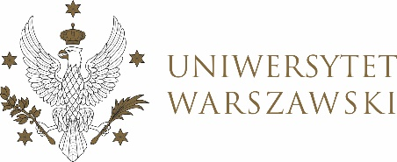

Journal of the University of Warsaw

TEACHING COUNCILS

Journal of the University of Warsaw

TEACHING COUNCILS FOR STUDIES

RESOLUTION NO. 11/2021

THE TEACHING COUNCIL FOR UNDERGRADUATE PROGRAMME IN INTERNATIONAL RELATIONS, UNDERGRADUATE PROGRAMME IN POLITICAL SCIENCE, GRADUATE PROGRAMME IN INTERNATIONAL RELATIONS, GRADUATE PROGRAMME IN POLITICAL SCIENCE, EUROPEAN POLITICS AND ECONOMICS
dated 15 March 2021,

on fees for educational services for students studying in a foreign language and for retaking courses and courses not covered by the study programme for the academic year 2021-2022

Pursuant to the provisions of section 68(2) of the Statute of the University of Warsaw
(Monitor UW of 2019, item 190) the Teaching and Learning Council adopts as follows:
§ 1
The Teaching Council approves the price list of educational services constituting Annex 1 to the resolution.
§ 2
This Resolution shall become effective on the day of its adoption.
Chairperson of the Teaching and Learning Council: D. Heidrich

